Private Mobile Network

🔒 What Is a Private Mobile Network?
# Source: AI Source: Provided by: [Data Path: Persons Table -> ID Column: 1, Name_En Column: Motasem Essam] -> From: [ChatGPT] on [1/23/2026]
A Private Mobile Network is a dedicated cellular network built for use by a specific organization, enterprise, or facility. Unlike public networks (run by MNOs like Vodafone or AT&T), a private mobile network is controlled and operated privately — often within a factory, airport, campus, or hospital.
🏭 It’s like having your own 4G/5G network, separate from the public one, with full control over speed, security, and connected devices.

🧩 Key Characteristics of Private Mobile Networks:
# Source: AI Source: Provided by: [Data Path: Persons Table -> ID Column: 1, Name_En Column: Motasem Essam] -> From: [ChatGPT] on [1/23/2026]
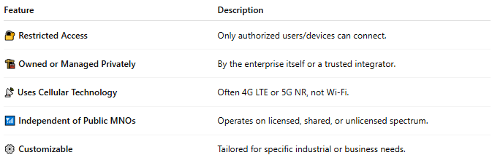

Feature | Description
🔐 Restricted Access | Only authorized users/devices can connect.
🏗️ Owned or Managed Privately | By the enterprise itself or a trusted integrator.
📡 Uses Cellular Technology | Often 4G LTE or 5G NR, not Wi-Fi.
📶 Independent of Public MNOs | Operates on licensed, shared, or unlicensed spectrum.
⚙️ Customizable | Tailored for specific industrial or business needs.

📊 Key Components:
# Source: AI Source: Provided by: [Data Path: Persons Table -> ID Column: 1, Name_En Column: Motasem Essam] -> From: [ChatGPT] on [1/23/2026]
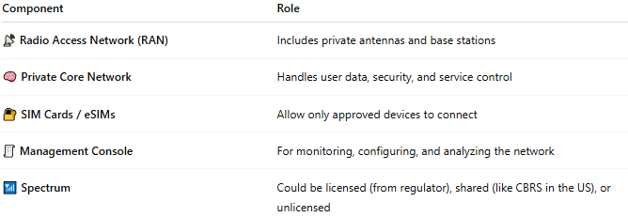

Component | Role
📡 Radio Access Network (RAN) | Includes private antennas and base stations
🧠 Private Core Network | Handles user data, security, and service control
🔐 SIM Cards / eSIMs | Allow only approved devices to connect
🧾 Management Console | For monitoring, configuring, and analyzing the network
📶 Spectrum | Could be licensed (from regulator), shared (like CBRS in the US), or unlicensed

🏭 Where Are Private Mobile Networks Used?
# Source: AI Source: Provided by: [Data Path: Persons Table -> ID Column: 1, Name_En Column: Motasem Essam] -> From: [ChatGPT] on [1/23/2026]
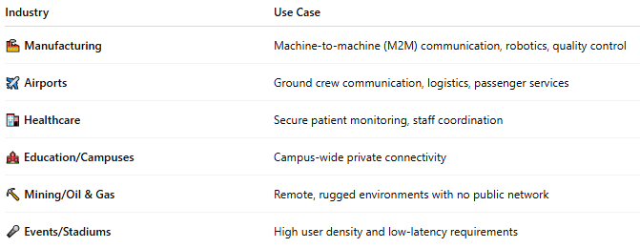

Industry | Use Case
🏭 Manufacturing | Machine-to-machine (M2M) communication, robotics, quality control
✈️ Airports | Ground crew communication, logistics, passenger services
🏥 Healthcare | Secure patient monitoring, staff coordination
🏫 Education/Campuses | Campus-wide private connectivity
⛏️ Mining/Oil & Gas | Remote, rugged environments with no public network
🎤 Events/Stadiums | High user density and low-latency requirements

✅ Benefits of Private Mobile Networks:
# Source: AI Source: Provided by: [Data Path: Persons Table -> ID Column: 1, Name_En Column: Motasem Essam] -> From: [ChatGPT] on [1/23/2026]
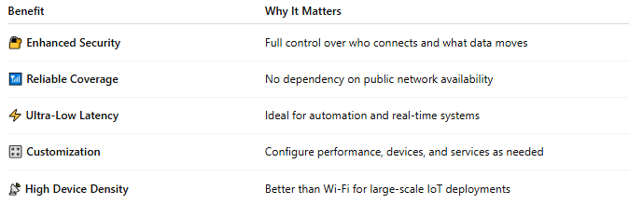

Benefit | Why It Matters
🔐 Enhanced Security | Full control over who connects and what data moves
📶 Reliable Coverage | No dependency on public network availability
⚡ Ultra-Low Latency | Ideal for automation and real-time systems
🎛️ Customization | Configure performance, devices, and services as needed
📡 High Device Density | Better than Wi-Fi for large-scale IoT deployments

🆚 Private vs Public Mobile Network:
# Source: AI Source: Provided by: [Data Path: Persons Table -> ID Column: 1, Name_En Column: Motasem Essam] -> From: [ChatGPT] on [1/23/2026]
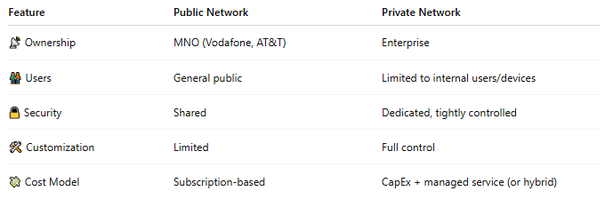

Feature | Public Network | Private Network
📡 Ownership | MNO (Vodafone, AT&T) | Enterprise
🧑‍🤝‍🧑 Users | General public | Limited to internal users/devices
🔒 Security | Shared | Dedicated, tightly controlled
🛠️ Customization | Limited | Full control
💸 Cost Model | Subscription-based | CapEx + managed service (or hybrid)

📖 Summary:
# Source: AI Source: Provided by: [Data Path: Persons Table -> ID Column: 1, Name_En Column: Motasem Essam] -> From: [ChatGPT] on [1/23/2026]
A Private Mobile Network is a dedicated cellular system, giving organizations:
- 🛡️ Full control over connectivity and security
- ⚡ High performance, reliability, and low latency
- 🔧 The ability to customize networks for industrial, medical, or enterprise needs

